Project Design Phase

Problem – Solution Fit Template

|  |  |
| --- | --- |
| Date | 24 june 2025 |
| Team ID | LTVIP2025TMID31490 |
| Project Name | HealthAI: intelligent healthcare assistant |
| Maximum Marks | 2 Marks |

Problem – Solution Fit Template:

✅ Problem–Solution Fit Template (Team Member-Focused)

Problem: Teams often face challenges with [specific issue related to team members], such as [examples of friction or inefficiencies]. This results in [negative impact on performance, morale, or productivity].

Solution: [Your product/tool/process] helps teams by [how it improves the team member experience or collaboration], leading to [positive measurable result]

Purpose:

The purpose of this code is to create a simple AI-powered health assistant that:

✅ Primary Objective:

To provide users with preliminary health insights based on their described symptoms using the IBM Granite large language model.

🛠 How it Works:

Takes user input for symptoms via the command line.

Constructs a natural language prompt describing the symptoms.

Sends the prompt to the IBM Granite 3.3-2b-instruct model (via Hugging Face).

Receives and displays AI-generated suggestions of possible medical conditions.

Provides a timestamped response to simulate a real-time assistant interaction.

💡 Why It's Useful:

Helps users understand potential causes of their symptoms.

Acts as a first-level triage tool before visiting a doctor.

Useful in rural or under-resourced settings where immediate consultation may not be available.

Demonstrates the power of LLMs in healthcare applications.

Template:

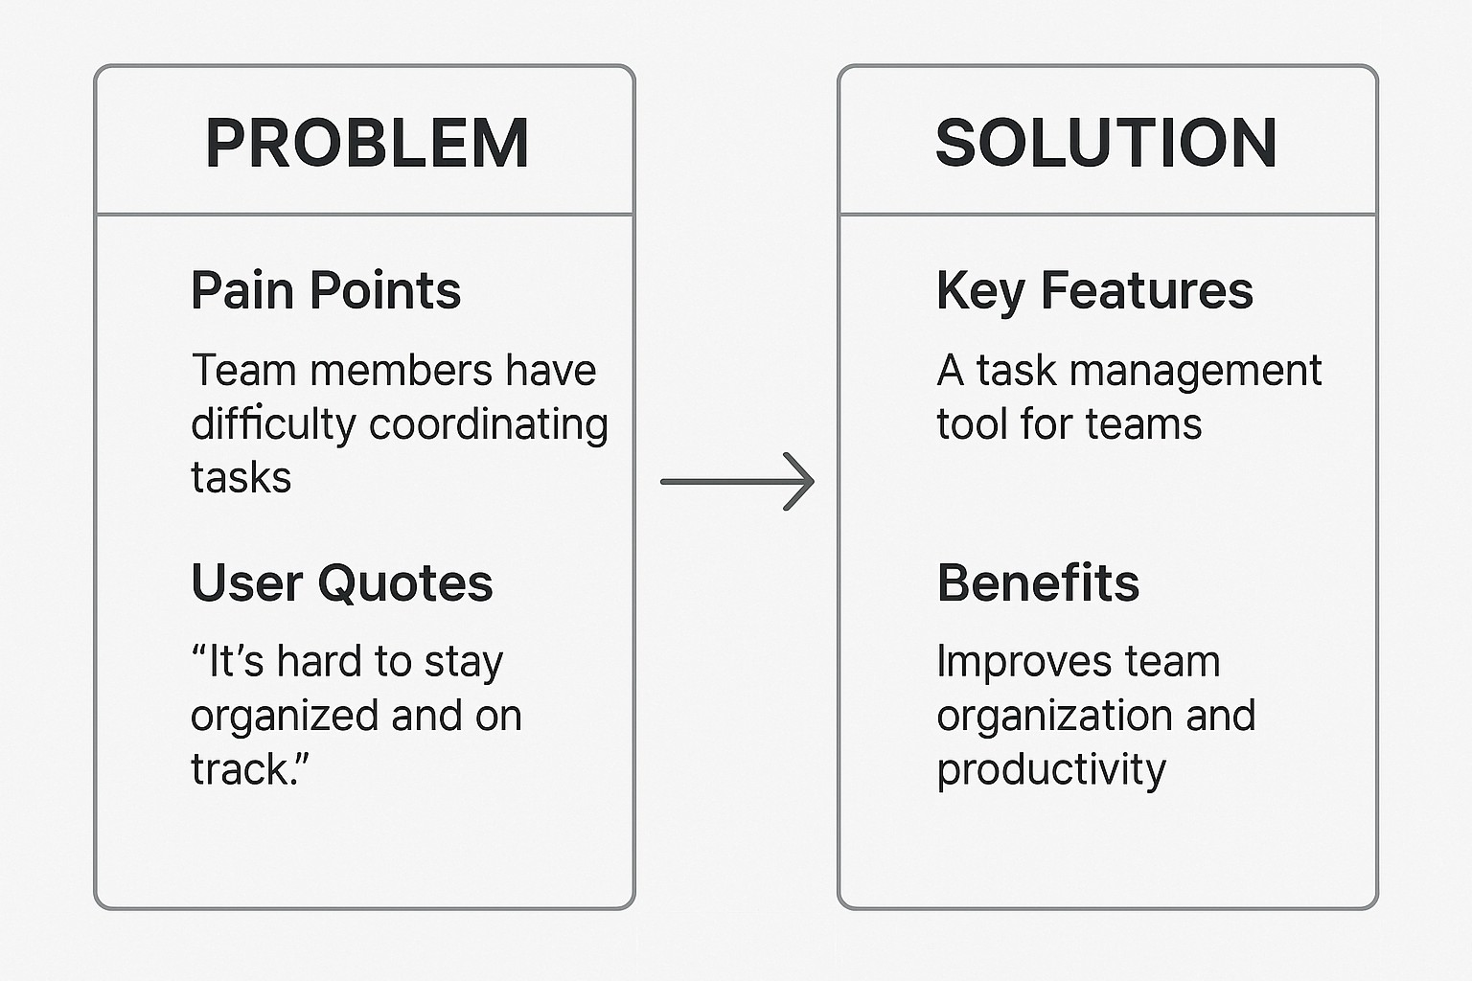

References:

1. https://huggingface.co/ibm-granite/granite-3.3-2b -instruct